### SYSTEM ANALYSIS AND DESIGN

### 2 SYSTEM DESIGN MODEL



Planning and requirement

gathering



Requirement analysis



Logical design of the

system



coding



Testing the system



Implementation and

training



Maintenance and support

Activities: The waterfall model is a popular version of the systems development life cycle model for software engineering. Often considered the classic approach to the system development life cycle, the waterfall model describes a development method that is linear and sequential. This model has the following activities;

Requirement & Analysis: this is also known as feasibility study where the system developer visits the client to study what the system requires. This establishes the requirements for all the system elements to be involved

### 3.3 DATA COLLECTION

For the art gallery management system project, data collection will involve gathering information from multiple sources to inform various aspects of system development, implementation and evaluation

1. Stakeholder interviews: Conduct interviews with key stakeholders, including citizens, emergency responders, administrators and relevant authorities. Gather insights into their needs, preferences, and expectations regarding the system
2. Surveys and Questionnaires: Distribute surveys and questionnaires to potential users and stakeholders to collect quantitative data on their experiences, opinions and requirements related to art gallery management system
3. Existing data analysis: Analyze existing data on art galleries, resource allocation and community demographics to identify patterns, trends, and areas for improvements
4. Case studies: Study similar systems implemented in other regions or jurisdictions to understand their successes, challenges, and best practices

##### 3.3.1 Sampling techniques

Sampling techniques will be employed primarily for surveys and questionnaires to ensure representative data collection from diverse user groups and stakeholders.

1. Stratified sampling: Divide the target into homogeneous groups eg(age groups, membership status), and sample proportionally from each group
2. Convenience sampling: Select artworks based on availability for review. Also, gather feedback from available staff members or administrators
3. Snowball sampling: Begin with a few key informants and ask them to recommend others who might provide valuable feedback

### 3.4 Data Analysis

Data analysis will involve descriptive, diagnostic, predictive, and prescriptive methods to derive meaningful insights and inform decision-making through the project lifecycle.

1. Descriptive Analysis: It summarizes and describes data characteristics. In artwork, it involves in counting and categorizing artworks by type, artist, or medium. In exhibition attendance trends it analyzes visitor attendance patterns over time or by exhibition theme. In sales performance, it calculates average sales per exhibition, best-selling artworks, or seasonal sales trends.
2. Diagnostic Analysis: It identifies relationships and patterns in data. Example is Correlation Analysis examines correlations between exhibition themes and visitor attendance, and Market-based analysis identifies associations between purchased artworks and visitor demographics, Sales performance by the artist it involves comparing sales performance across different artists represented in the gallery
3. Predictive Analysis: It forecasts future trends and behavior based on historical data. Examples of visitor forecasting it involve predicting future visitor attendance based on historical patterns and upcoming exhibitions. In artwork sales prediction it involves forecasting sales trends for specific artworks based on historical sales data and market conditions. Also in exhibition success prediction, it involves predicting the success of future exhibitions based on past attendance and popularity
4. Prescriptive Analysis: Its purpose is to recommend actions or strategies based on data insights. In optimizing exhibition planning it suggests optimal exhibition themes or artwork selection based on past visitor preferences. In inventory management, it involves recommending inventory levels and replenishment strategies based on sales trends on sales trends and exhibition schedules. In marketing strategies, it involves advising on targeted marketing campaigns based on visitor demographics and behavior.

### 3.5 LIMITATIONS OF THE STUDY

Reliance on existing data within the art gallery management system may be limited by completeness, accuracy, or timeliness affecting the robustness of analysis and conclusions. Challenges in accessing key stakeholders (gallery staff, artists, visitors) for interviews or surveys may constrain data collection efforts.

Potential biases in sampling methods (prescriptive analysis) could skew results and limit the representativeness of findings. Limitations in the design of the research study may impact the depth and breach of insights gathered.

Changes in economic conditions or art market dynamics could influence the relevance and applicability of research findings over time. Compliance with regulatory requirements eg (data privacy laws intellectual property) may impose constraints on data collection and analysis

# 4.0CHAPTER FOUR

### 4.1 SYSTEM ANALYSIS AND REQUIREMENT MODELLING

##### 4.1.1 Flowchart

It involves the system by using diagram as shown below



Admin log in id and

password



Check

login id

and



start



Admin is

registered



Invalid login/password



End



Log in to the

system



Set user levels and

permissions



Access the internal

functionalities according to

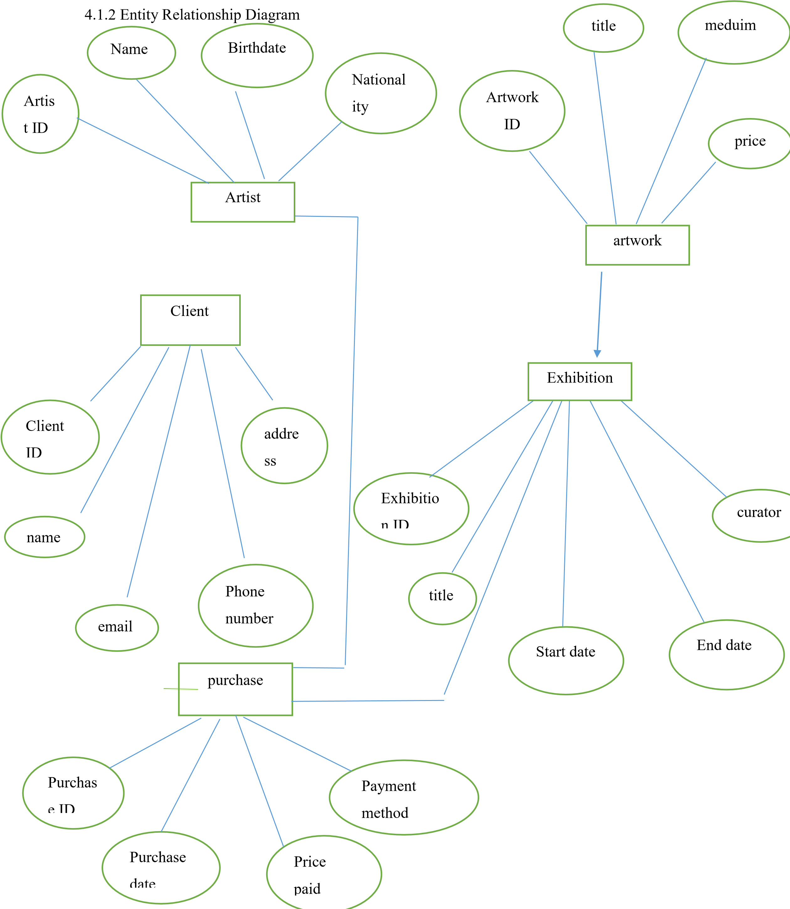

##### 4.1.3Dataflow diagram

Art Gallery

Management system

Manage Manage artists vvartwork

Add, remove Add, artists remove

View artists View

artworks

Manage Manage exhibitions reports



Schedule cancel Generate exhibits reports

##### 4.1.4 Context diagram



Art gallery

system



Art gallery staff



Artists



Customers

# REFERENCES

* Glen ford J. Meyers, Corey Sandler, and Tom Badget (1979)The Art of software Testing

* Sandra M, Correla (2016) Managing the Brand of Art Gallery. Art Visualization and Overall Evaluation

* Beck, k et al (2001). The Agile Manifesto. Agile alliance https://agilemanifesto.org/

* Smith J (2021) Implementing an efficient art inventory systems: Lessons from the field. In proceedings of the International Conference on Art and Technology

* Doe, J, et al (2019). A study on the Usability of an Online Art Gallery. Journal of Digital Art Management, 15(2)

* Myers, G J Sandler, C, and Badget, T.(2011)The Art of Software testing. John Wiley & Sons

* Green M (2018) “The Impact of Technology in Art Gallery Management. Art Management Journal 2018

* Gamma, E, Helm, R, Johnson, R, and Vlissides, J. (1994) Design Patterns Elements of Reusable Object-Oriented Software Addison Wesley Professional

* Silbertchatz, A, Korth, H, F,, &Sudarshan, S (2010). Database System Concepts McGraw-Hill Education